# The Regular Present Tense - Part 1

* The infinite of German words normally end with (**EN**: **infinite suffix**)
* Kauf**en** (to buy)
* Mack**en** (to make)
* Geh**en** (to go)
* Hab**en** (to have)

**Plural** form: Regular | **Singular** form: **Irregular**

* First part of the verb is called **STAMM.** It will remain **unaltered/unchanged** during the present tense.

**Ex: KAUF**EN - To Buy

* **(I buy) -** Ich **kaufe-** First person singular added **“e”**
* **(You buy - Informal) -** Du **kaufst-** Second person singular added **“st”**
* **(He/She/ It buys) -** Er/Sie/Es **kauft -** Third person singular added **“t”**
* **(We buy) -** Wir **kaufen -** First person plural added **“en”**
* **(You buy - Plural) -** Ihr **kauft -** Second person plural added **“t”**
* **(They buy) -** Sie **kaufen -** Third person plural added **“en”**
* What is the **Stamm** of the verb **MACHEN (to make)**?
* Answer: **MACH**
* Ich **macht - (I make)**
* Du **machst - (You make)**
* Er/ Sie / Es **macht - (He /She/ It makes)**
* Wir **machen - (We make)**
* Ihr **macht - (You (Plural) make)**
* Sie **machen - (They/You (formal) make)**
* What is the Stamm of the verb **Gehen (to go)**?
* Answer: **Gehn**
* Ich **gehnt** - (**I go)**
* Du **gehnst** - **(You go)**
* Er/ Sie / Es **gehnt** - (**He /She/ It goes)**
* Wir **gehnen** - (**We go)**
* Ihr **gehnt** - **(You (plural) go)**
* Sie **gehnen** -  **(They/You (formal) go)**
* What is the Stamm of the verb **Haben (to have)**?
* Answer: **Hab**
* Ich **habe - (I have)**
* Du **hast - (You have)**
* Er/Sie/Es **hat - (He/She/It has)**
* Wir **haben - (We have)**
* Ihr **habt - (You (plural) have)**
* Sie **haben - (They/You (formal) have)**

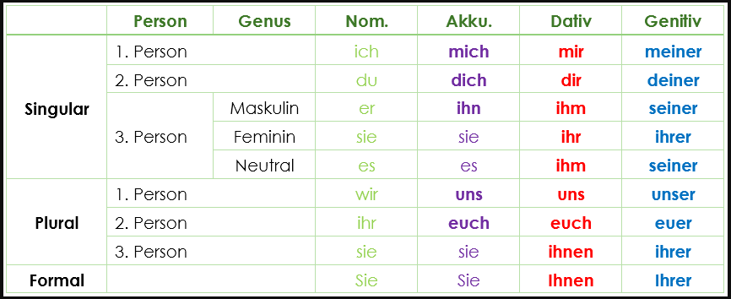

**References**:

1. <https://youtu.be/Op6DTpDE3_k?si=fgD5miywNODqT-IH>
2. <https://www.thegermanprofessor.com/present-tense-verbs/>
3. <https://germanwithlaura.com/verb-conjugations/>
4. <https://ielanguages.com/german-regular-verbs.html>